INTEGRATIVE COURSE IN PSYCHOLOGY (ICOPSYCH)

ANALYSIS ON THE RESULT OF POST-TEST EXAMINATION IN ABNORMAL PSYCHOLOGY
MARCH 22, 2025

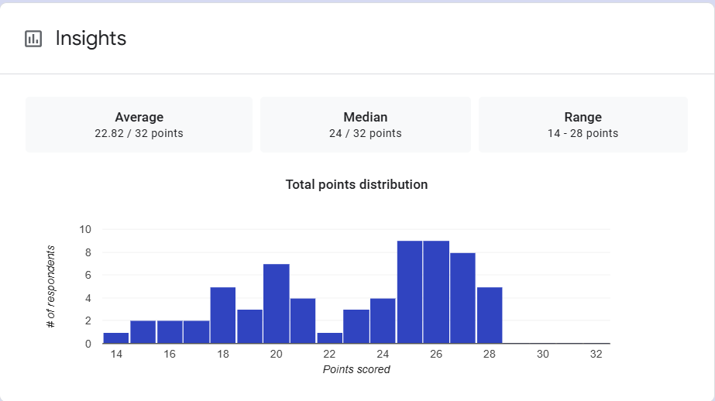

1. Mean Score: The average score of all the participants is approximately 22.82 out of 32 points. This indicates that, on average, the group performed slightly above the midpoint of the scoring range (which is 16 out of 32). A mean of 22.82 suggests that most students were able to score reasonably well, though not exceptionally high.

2. Median Score: The median score is 24, which means that 50% of the participants scored below 24 and 50% scored above 24. This score being slightly higher than the mean (22.82) suggests a slight skew towards higher scores. In other words, more participants performed better than the average score, which may imply that the exam was not too difficult for many.

3. Range: The range of scores spans from 14 to 28 points. This indicates that the lowest score achieved was 14, while the highest score was 28. The relatively narrow range (14 points between the lowest and highest scores) suggests that most participants' scores were clustered relatively closely together, with no extreme outliers or extremely low-performing individuals.

Interpretation Summary:

-The overall performance of the participants is fairly good, with an average score of 22.82 out of 32, and a median score indicating that half of the participants scored above 24 points.

-The range between the lowest (14) and highest (28) scores is moderate, implying that most participants had scores within a similar range, without significant disparities in performance.

-The distribution of scores may be skewed slightly towards the higher end, as the median score is higher than the mean.
RATIONALIZATION:

DIFFICULT QUESTIONS:

